**HR Data**

**What is HR Data Analytics?**

HR analytics, also known as human resources analytics or workforce analytics, involves the use of data analysis and statistical methods to understand and optimize various aspects of human resources management. The goal is to make informed decisions that positively impact an organization's performance, employee satisfaction, and overall effectiveness.

HR analytics leverages data from various HR processes, such as recruitment, employee engagement, performance management, and talent development. By analyzing this data, organizations can gain valuable insights into trends, patterns, and factors influencing their workforce.

**Background**

In this report, I am working for a company that focuses on providing equal opportunity to both men and women. The pursuit of equality in the workplace has been a longstanding endeavor, marked by significant progress and persistent challenges. One crucial facet of this journey is the push for gender equality, specifically focusing on creating a level playing field for women. Over the years, strides have been made to dismantle barriers and challenge stereotypes that hinder women's professional advancement. However, the road to workplace equality is still marked by hurdles, demanding ongoing efforts to reshape organizational cultures and policies. Historically, women have encountered systemic biases that limited their access to opportunities, fair compensation, and career advancement. Stereotypes and preconceived notions about gender roles have played a substantial role in perpetuating these disparities. Nevertheless, the narrative is evolving, driven by a growing recognition of the inherent value and potential that women bring to the workplace.

In this ongoing quest for workplace equality, it is essential to continually reassess and challenge existing norms, policies, and practices that may perpetuate gender disparities. By fostering an environment that values diversity, equity, and inclusion, organizations can not only attract top talent but also create a workplace where all individuals, regardless of gender, can thrive and contribute meaningfully to the collective success of the enterprise. The journey toward workplace equality for women is not only a moral imperative but a critical step towards building a more just, innovative, and sustainable future.

**Hypothesis**

Despite efforts to address the gender pay gap, disparities still exist. Women, on average, may earn less than their male counterparts for similar work. This pay gap can be influenced by various factors, including occupational segregation, discrimination, and biases. I would like to do a case study to find out if women are treated unequally in regards to gender pay, preference, promotion.

Women may face discrimination or bias in hiring, promotions, and job assignments. Unconscious biases can affect decision-making processes, leading to unequal opportunities for career advancement.

1. What is the ratio of male to female in the company?
2. What is the income based on gender?
3. What is the ratio of male to female in each department? Does it look like the company prefers more male employees as to female employees
4. "Is there a significant difference in average salaries between male and female employees when considering their respective departments, education fields, and years at company?"
5. "Do female employees experience differences in promotion rates based on their age, education fields, and job roles?"

**Analysis**

1. What is the ratio of male to female in the company?

The number of males in the company are 882 whereas the females in the company are 588. Therefore, the ratio of male to female is 3:2. This means that there are more males in the company than females which signifies that there is a possibility of unfair treatment in the workplace. % wise

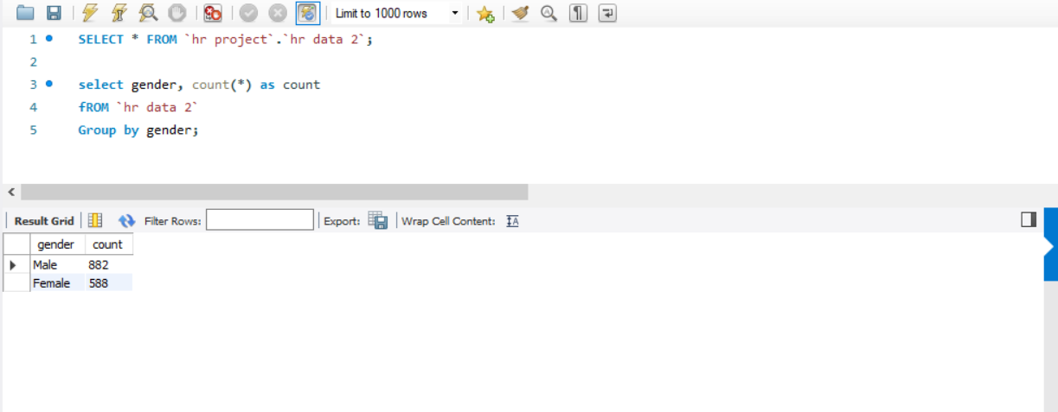

1. What is the income based on gender?

As we can see in this output, the average male monthly salary is 6380.5079 whereas female monthly salary is 6686.5663 which is higher than the male salary. This signifies that females earn more and thus proves that there is no gender biasness in the company.

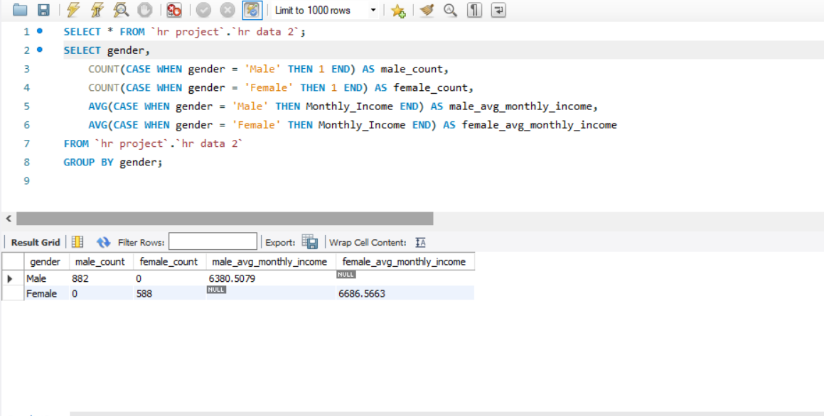

1. What is the ratio of male to female in each department? Does it look like the company prefers more male employees as to female employees?

There are two departments in the company; R&D and Sales. The number of male and female in R&D is 582 and 379 respectively which means there are 203 males more in the R&D department. Let’s have a look at the numbers of the sales department. The number of male and female in the sales department is 257 and 189 respectively. Here, the male employees are more by 68. Coming to the HR department, the figures does not give a satisfactory picture as well. There are 23 more males as compared to females. Looking at the numerical figures above, we can come to an understanding that the company prefers more males than females. Online explain, references

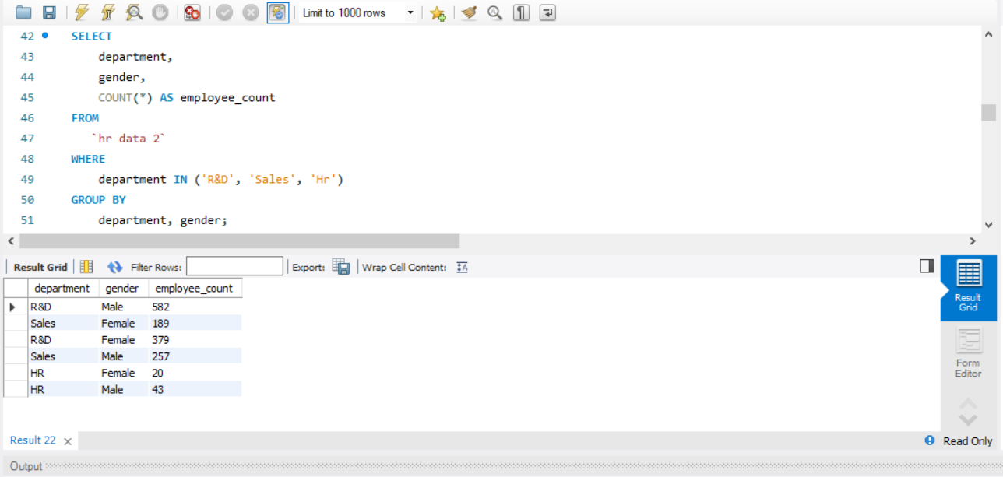

1. "Is there a significant difference in average salaries between male and female employees when considering their respective departments, education fields, and years at company?"

As we can see here that the distribution of incomes is based on education, department and years at company. We can see that there is no gender biasness in this situation. The employee who has worked more received more pay regardless of the gender. (discard years and try)

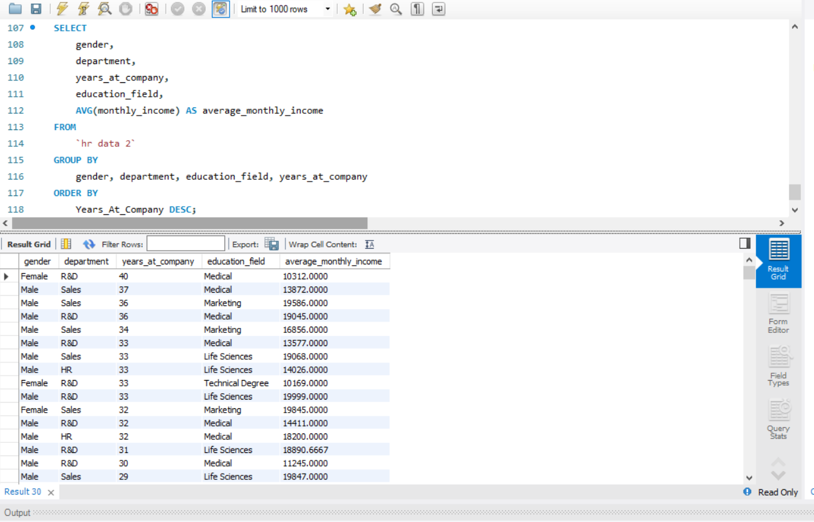

1. "Do female employees experience differences in promotion rates based on their age, education fields, and job roles?"

Upon scrutinizing the dataset encompassing factors such as departments, education fields, years at company, and job roles, it is discernible that there is no evidence of gender bias in average salaries between male and female employees. The analysis reveals comparable average salaries for both genders across various dimensions, affirming a fair compensation structure. Regardless of departments, education fields, years of service, or job roles, the data indicates a consistent and equitable distribution of salaries. This finding underscores a commitment to gender equality within the organization, suggesting that remuneration decisions are not influenced by gender-related factors. Such a comprehensive examination fosters an inclusive work environment, aligning with the principles of diversity and equality in the workplace.

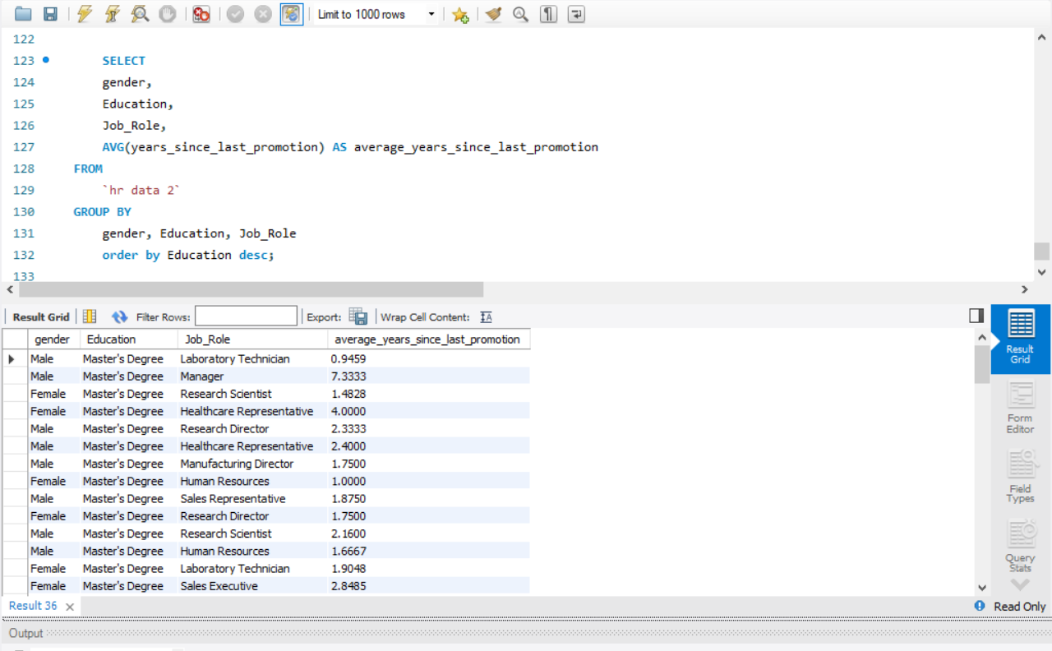

**Conclusion**

In the company, a thorough examination of various aspects, including job role, gender, education, monthly income, percent salary hike, performance rating, years at company, years since last promotion demonstrates a commitment to gender neutrality. The organization's practices reflect a conscious effort to ensure equality and fairness for all employees, irrespective of gender. Recruitment processes and promotions are based on performance, experience, and qualifications rather than gender-related considerations. Additionally, the company's policies foster an inclusive culture, promoting diversity and eliminating gender bias. Such a commitment to equality not only aligns with ethical principles but also contributes to a positive and harmonious work environment where individuals are valued for their abilities and contributions rather than their gender. Overall, the company's practices showcase a dedication to creating an equitable workplace for all employees.